BUSINESS INTELLIGENCE AND TOOLS- ASSIGNMENT 1
Aim
To perform data preprocessing, Exploratory Data Analysis (EDA), Star Schema modeling, and OLAP operations such as slicing, dicing, drill-down, and roll-up on a sales dataset using Microsoft Power BI.
Objectives
- To preprocess and clean the sales dataset using Power Query.
- To perform Exploratory Data Analysis (EDA) and understand the data distribution and patterns.
- To design a Star Schema using fact and dimension tables and establish relationships.
- To perform OLAP operations such as Slicing, Dicing, Drill-Down, and Roll-Up for multidimensional sales analysis.
Tools Required
- Microsoft Power BI Desktop
- Power Query Editor
- Sales dataset
Theory
4.1 Data Preprocessing
Data preprocessing is the process of preparing raw data for analysis. It includes:
- Removing unnecessary data
- Handling missing values
- Correcting data types
- Renaming columns
- Removing errors and duplicates
- Transforming data into a suitable format
In Power BI, Power Query Editor is used to perform these operations before loading the data into the data model.
4.2 Exploratory Data Analysis (EDA)
EDA is used to understand the structure, quality, distribution, and patterns present in a dataset.
It helps identify:
- Number of records and columns
- Data types
- Missing or empty values
- Unique and distinct values
- Errors and inconsistencies
- Distribution of categorical and numerical data
- Relationships and patterns in the data
Power Query's Column Quality, Column Distribution, and Column Profile features can be used for initial data profiling.
4.3 Star Schema
A Star Schema is a data-modeling technique in which a central Fact Table is connected to multiple Dimension Tables.
For the sales dataset:
Fact Table:
- FactSales
Dimension Tables:
- DimDate
- DimGeography
- DimProduct
- DimSalesChannel
The fact table contains measurable business data such as NetSales, CostPrice, Profit, DiscountPct, etc., while dimension tables contain descriptive information used for analysis.
The relationships created are:
- FactSales[City] → DimGeography[City]
- FactSales[OrderDate] → DimDate[OrderDate]
- FactSales[ProductCategory] → DimProduct[ProductCategory]
- FactSales[SalesChannel] → DimSalesChannel[SalesChannel]
The many-to-one relationship allows multiple sales records in the fact table to be associated with one record/value in a dimension table.
4.4 OLAP Operations
- OLAP (Online Analytical Processing) allows multidimensional analysis of data.
- Slicing: Selecting a single dimension/value to view a specific subset of data.
Example: Region = West
- Dicing: Selecting values from multiple dimensions to analyze a smaller subset.
Example: Region = West + Product = Software + Channel = Online
- Drill-Down: Moving from a higher-level summary to more detailed information.
Example: Year → Quarter → Month → Day
- Roll-Up: Moving from detailed information to a higher-level summary.
Example: Day → Month → Quarter → Year
Procedure:
Part A: Data Preprocessing
Step 1: Import the Dataset
- Open Power BI Desktop.
- Import the sales dataset using Get Data.
- Open the dataset in Power Query Editor.

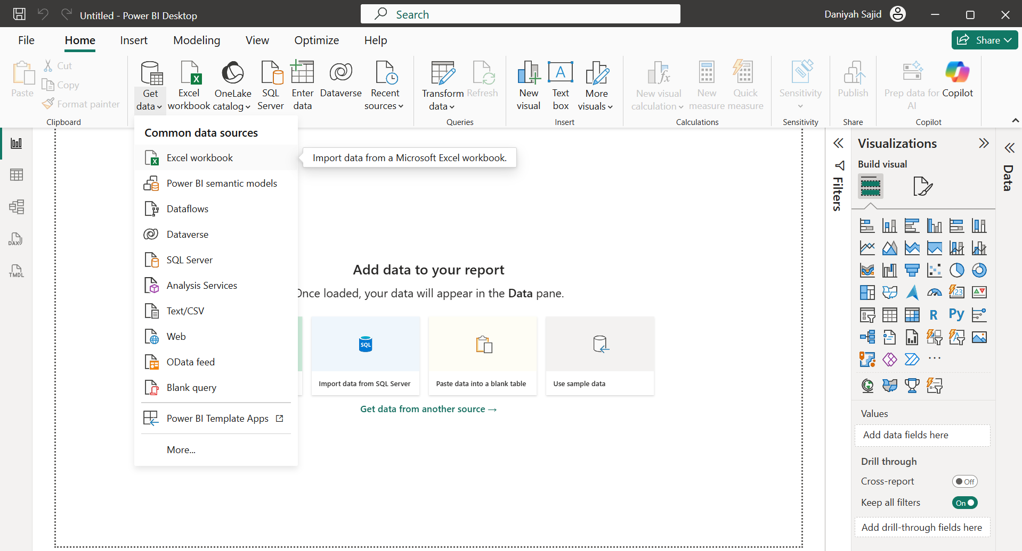

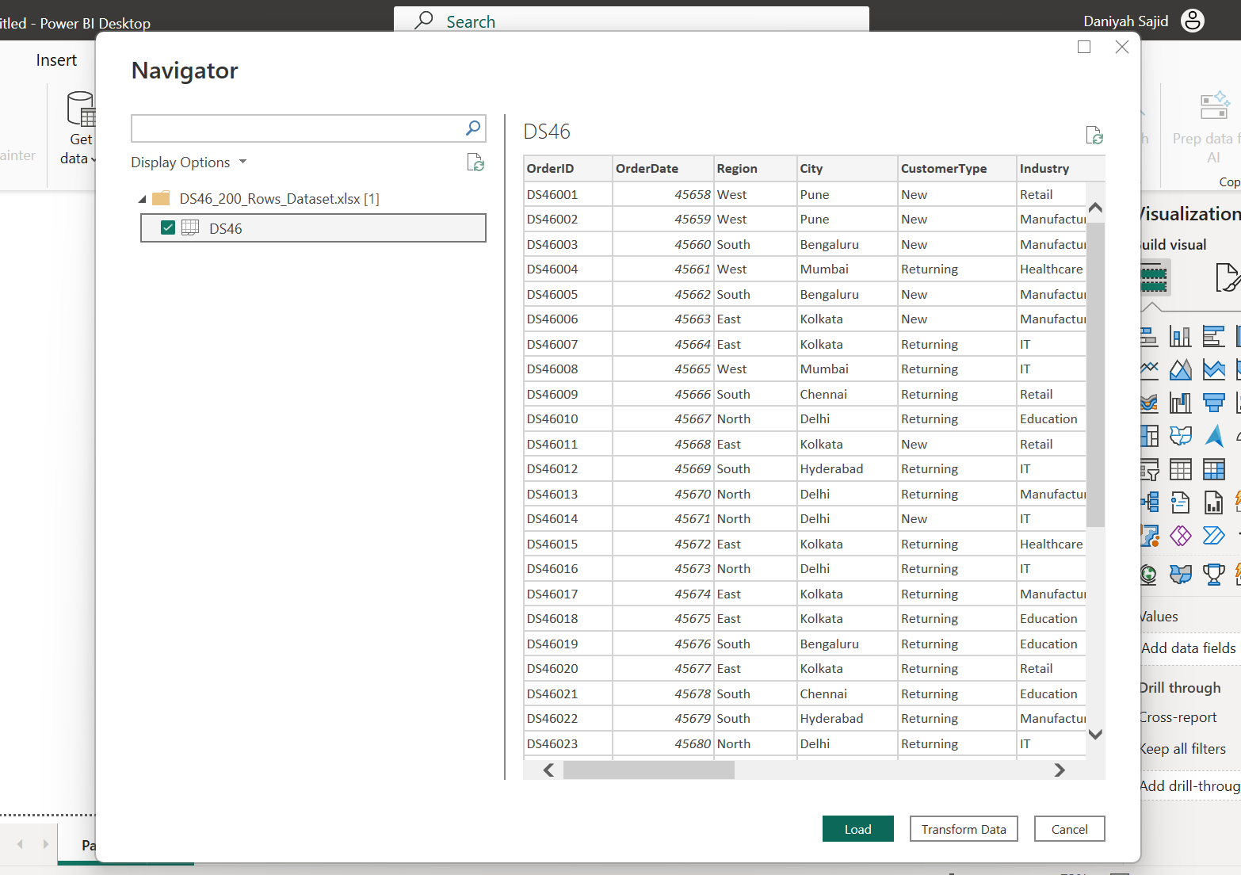

Step 2: Inspect the Data
- Examine the available columns and records.
- Check the data types of each column.
- Identify numerical, categorical, and date columns.
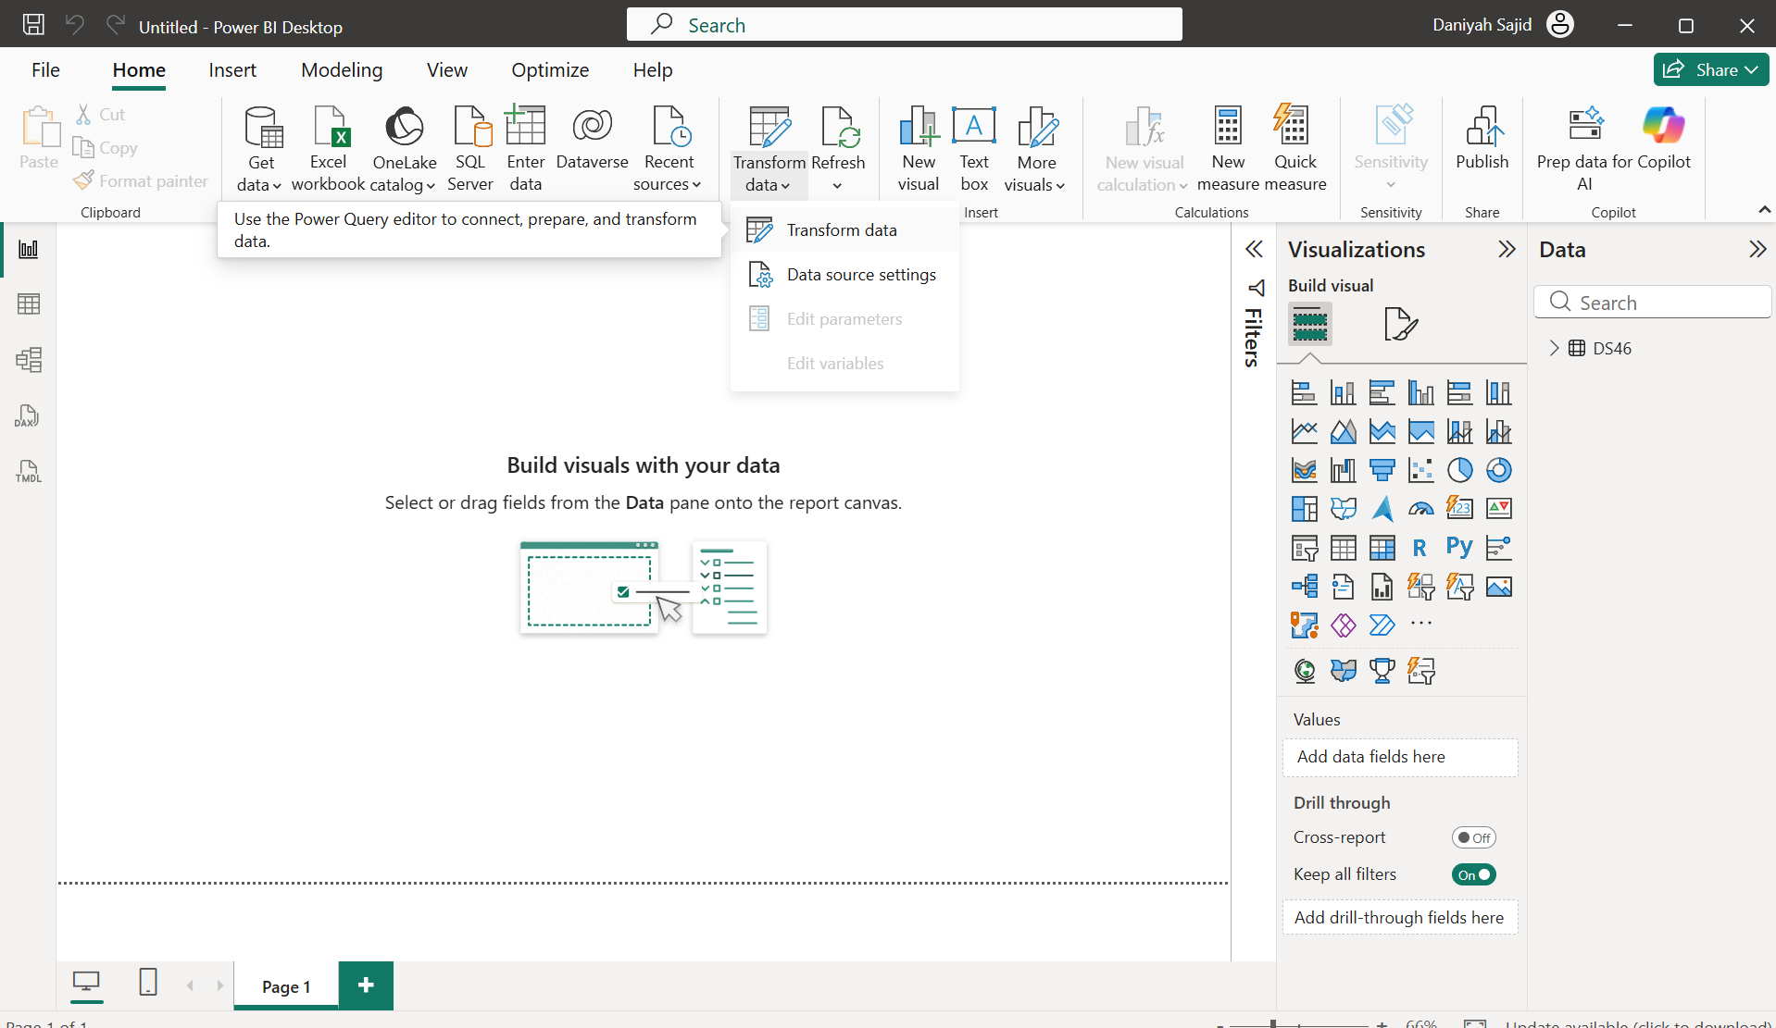

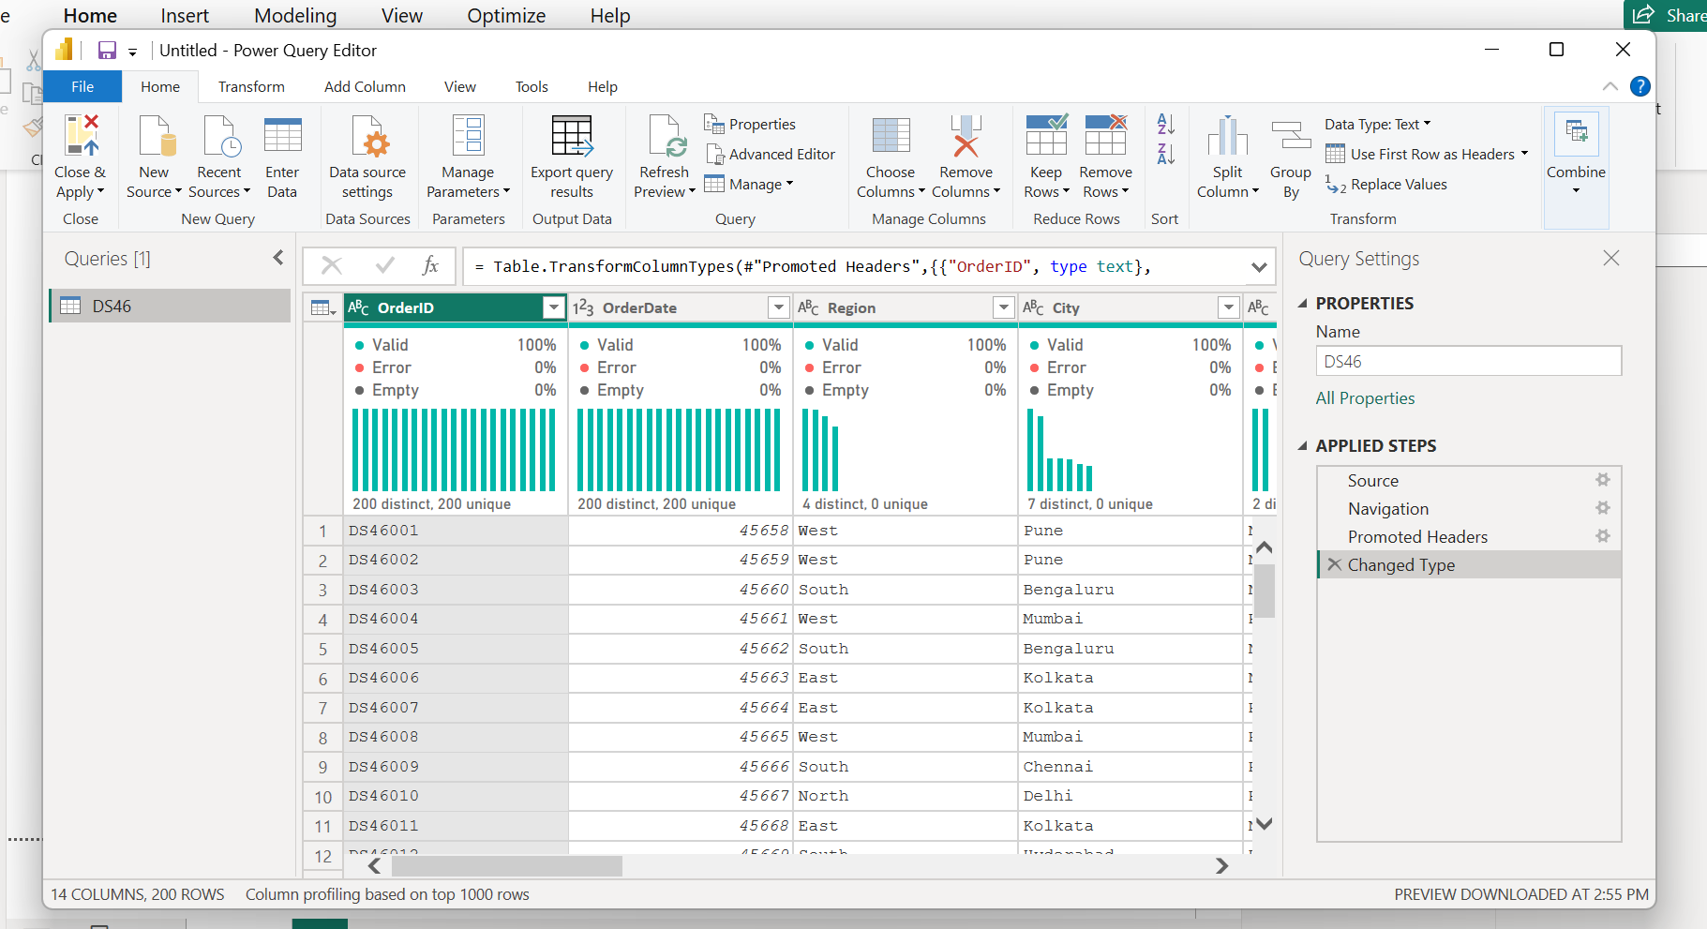
Step 3: Perform Data Cleaning
- Remove unnecessary columns, if any.
- Rename columns where required.
- Correct incorrect data types.
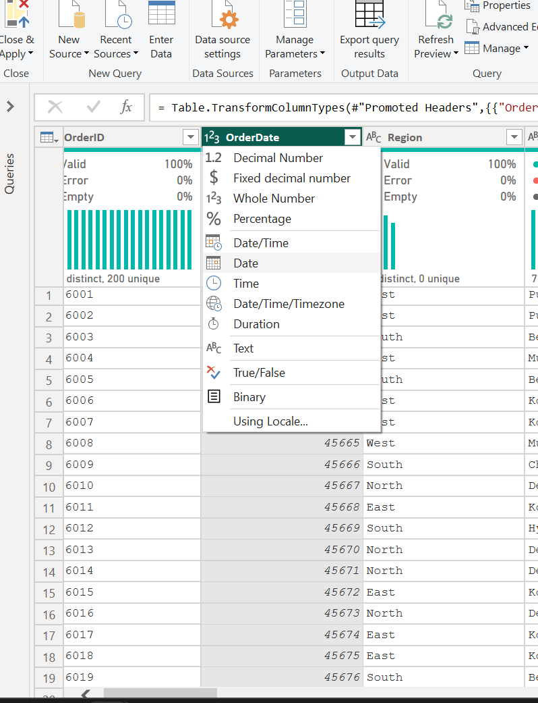

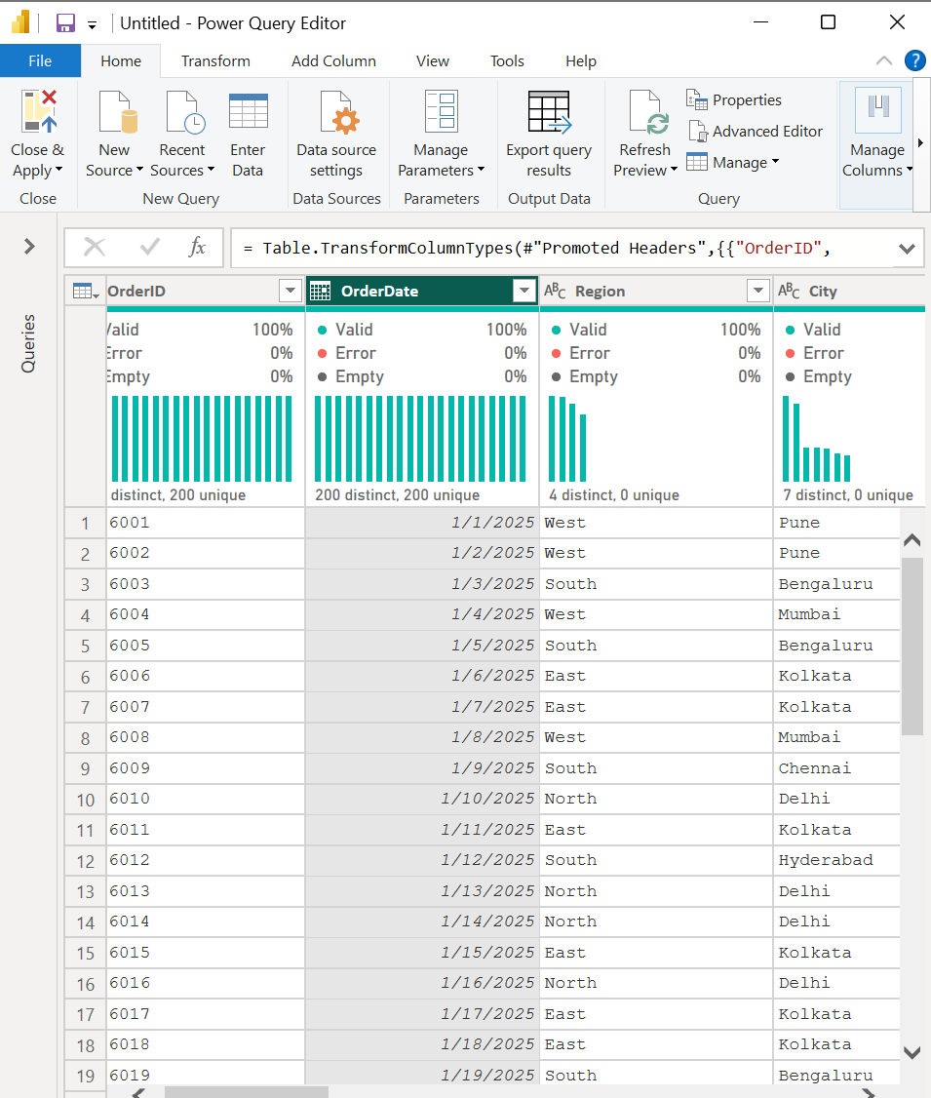

- Check for null/empty values.
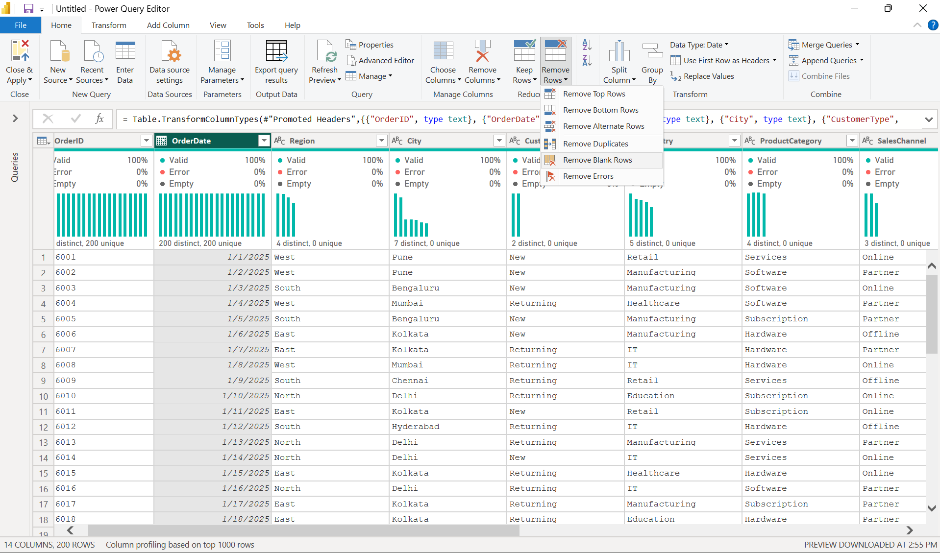

- Check for errors and inconsistent values.
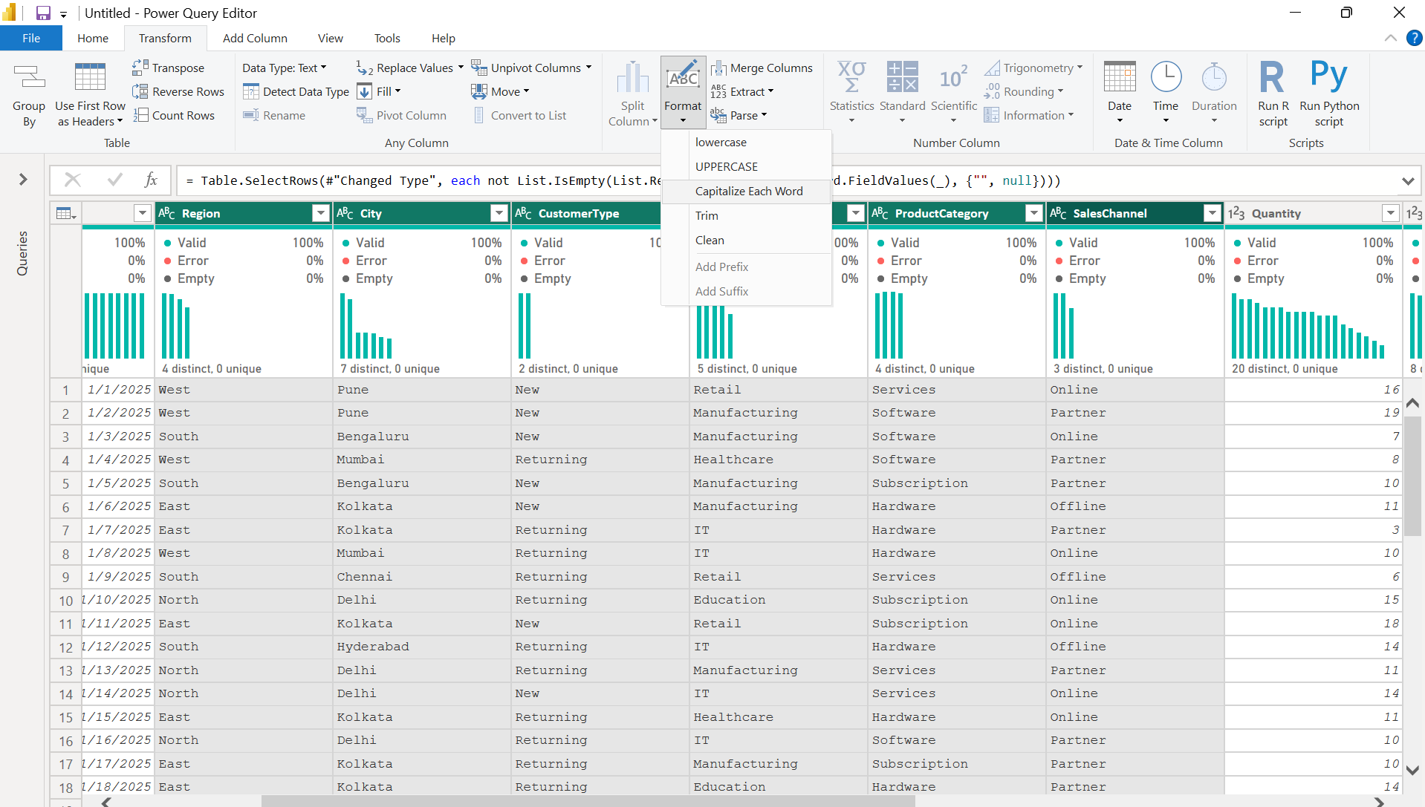
- Remove duplicate records wherever required.
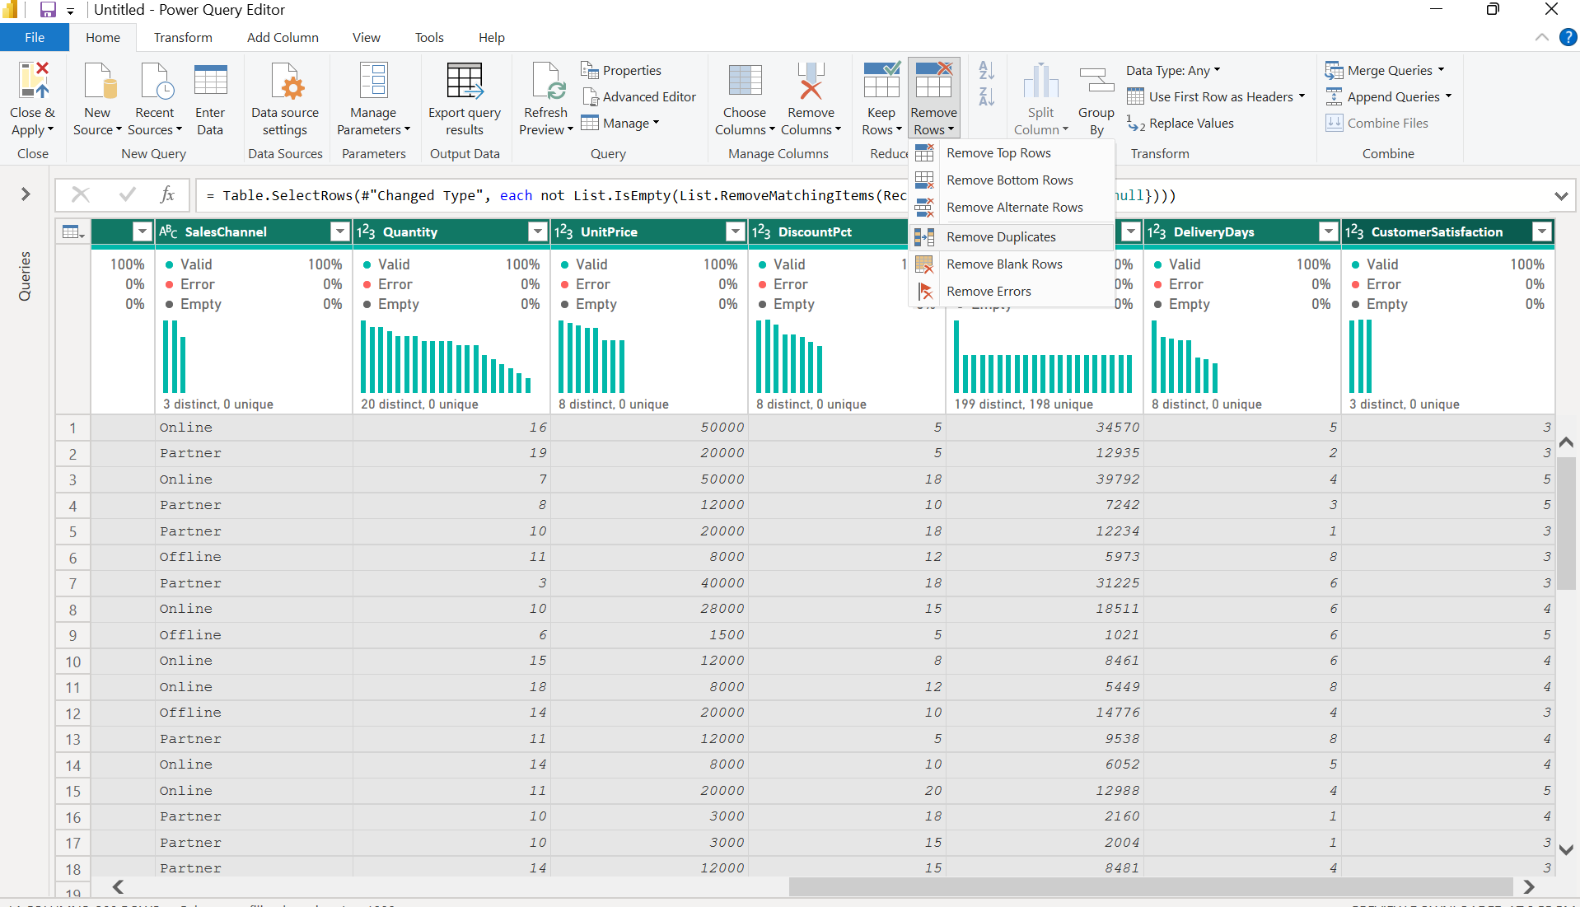
- Create necessary columns
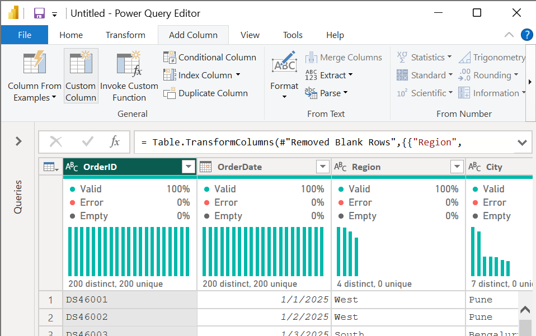
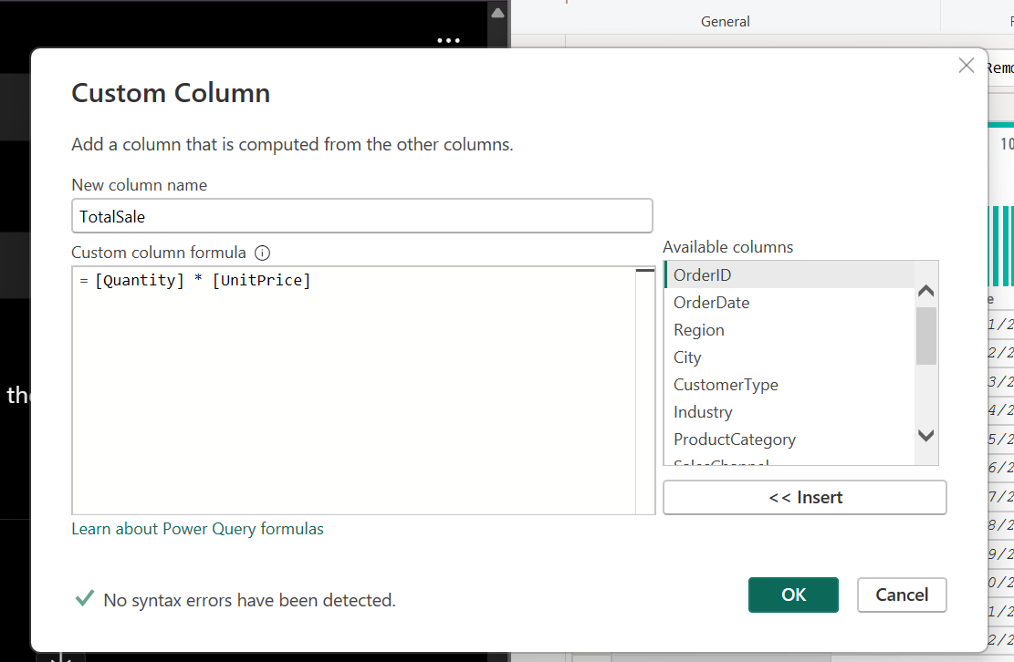

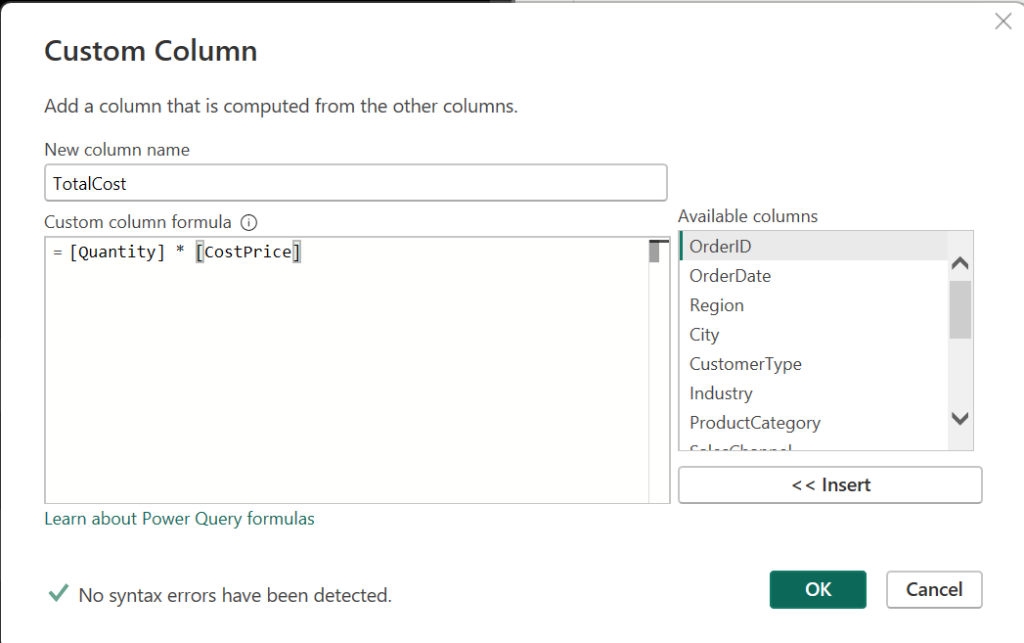
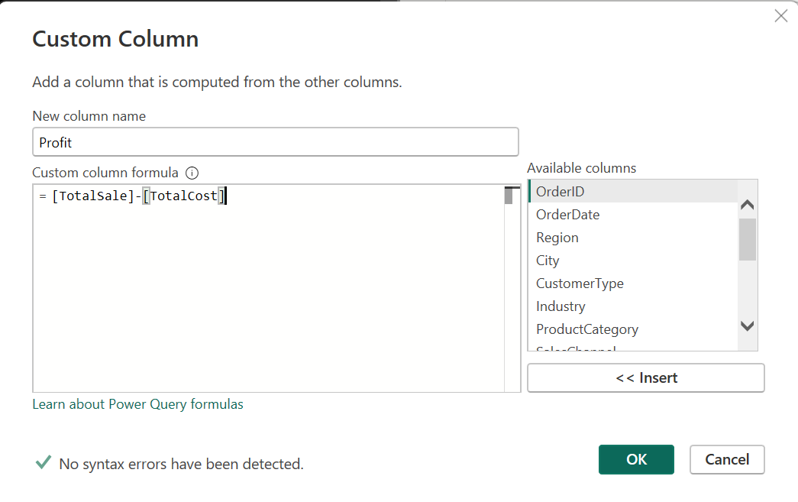
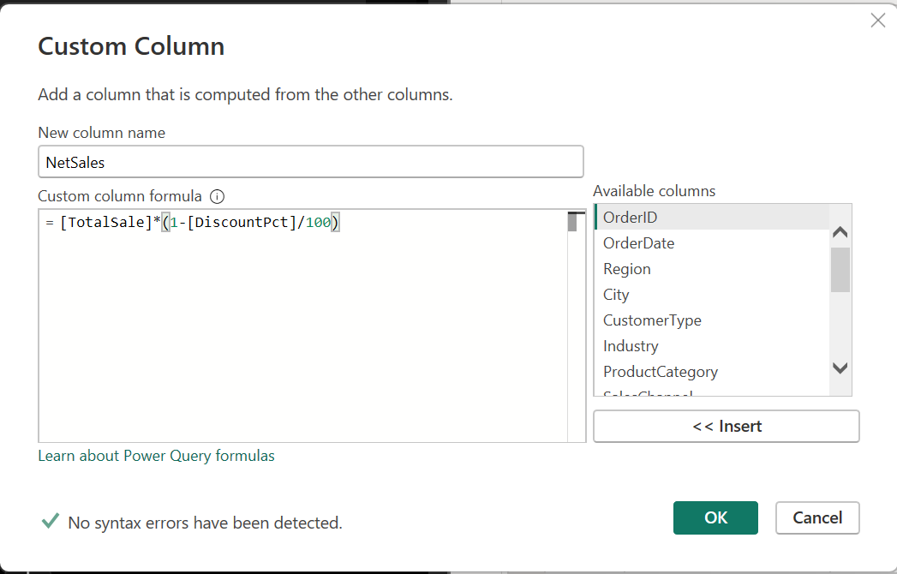

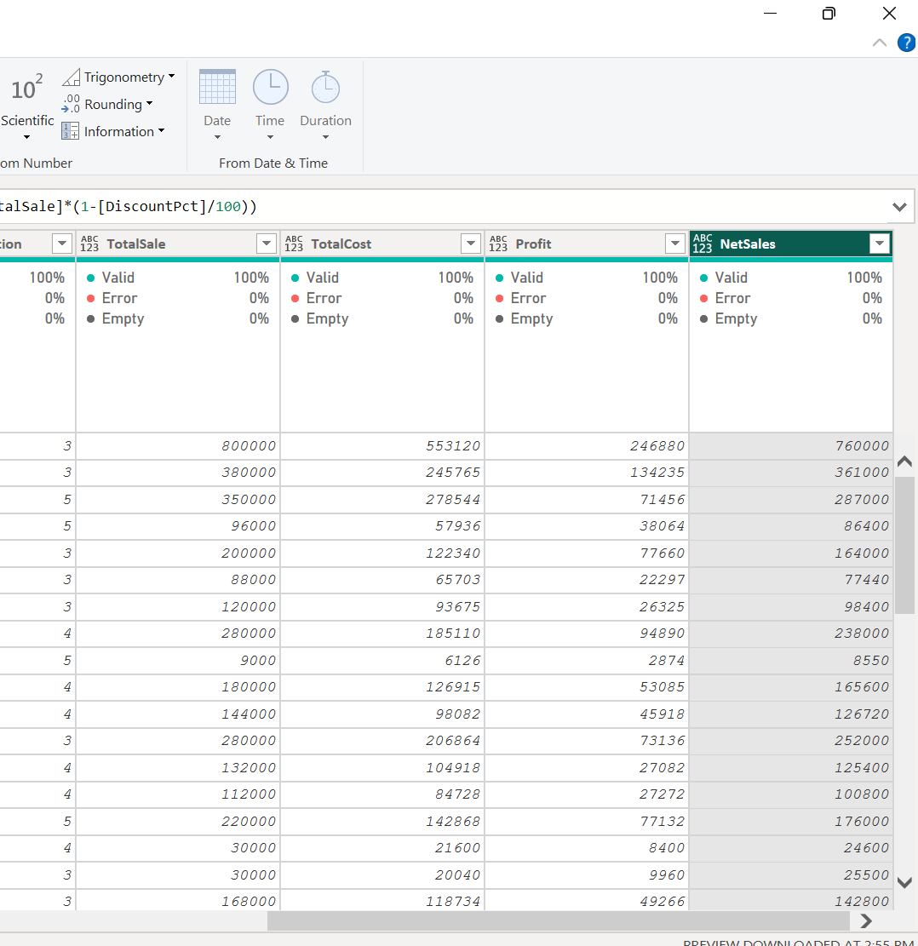

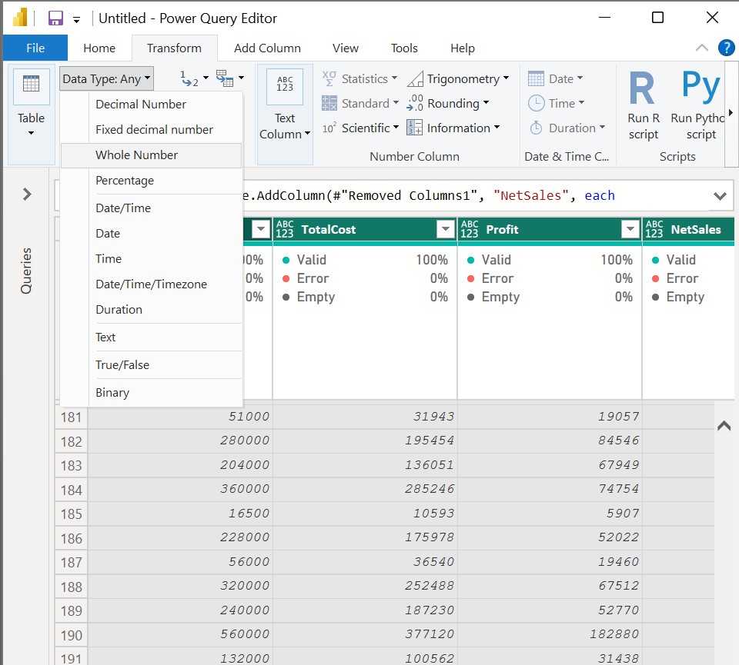

Step 4: Create Dimension Tables
Create separate dimension tables from the required attributes:
- DimDate
- DimGeography
- DimProduct
- DimSalesChannel
The cleaned transaction data is maintained as the FactSales table.

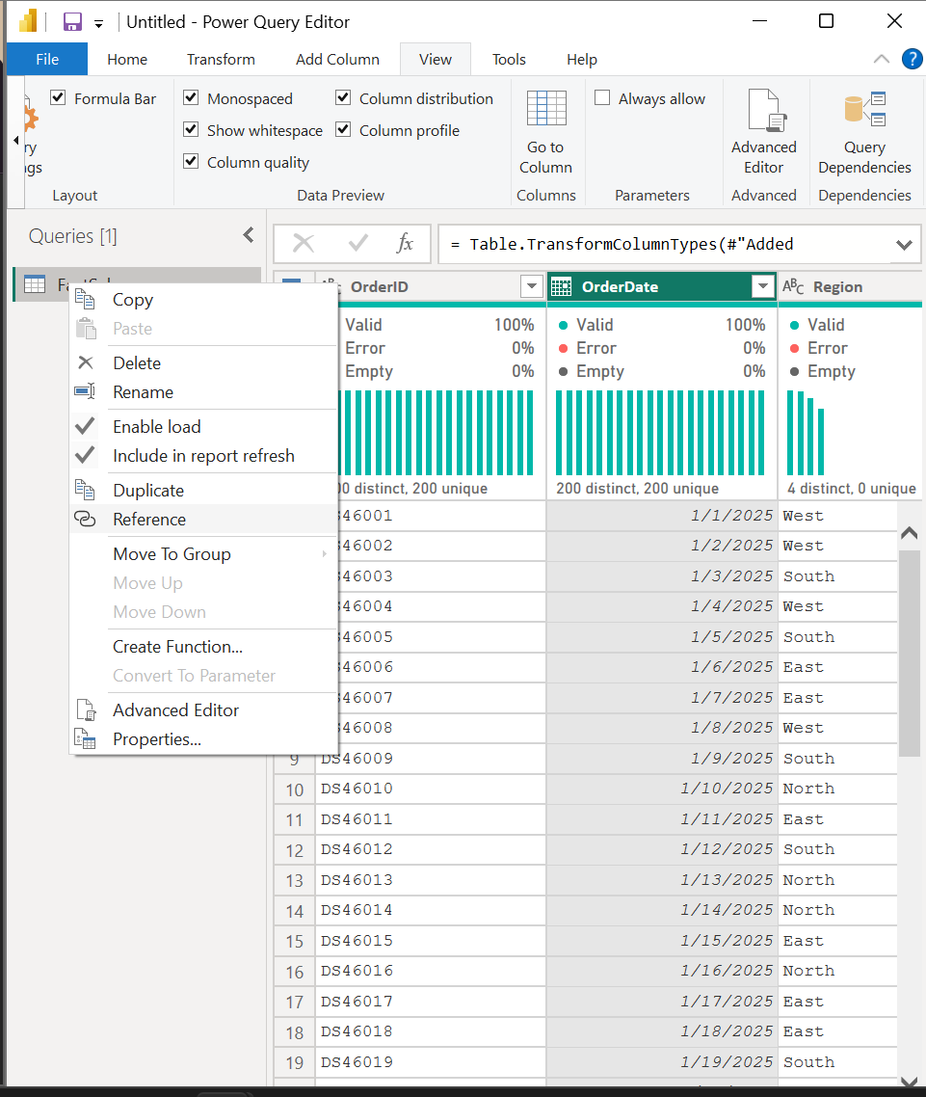

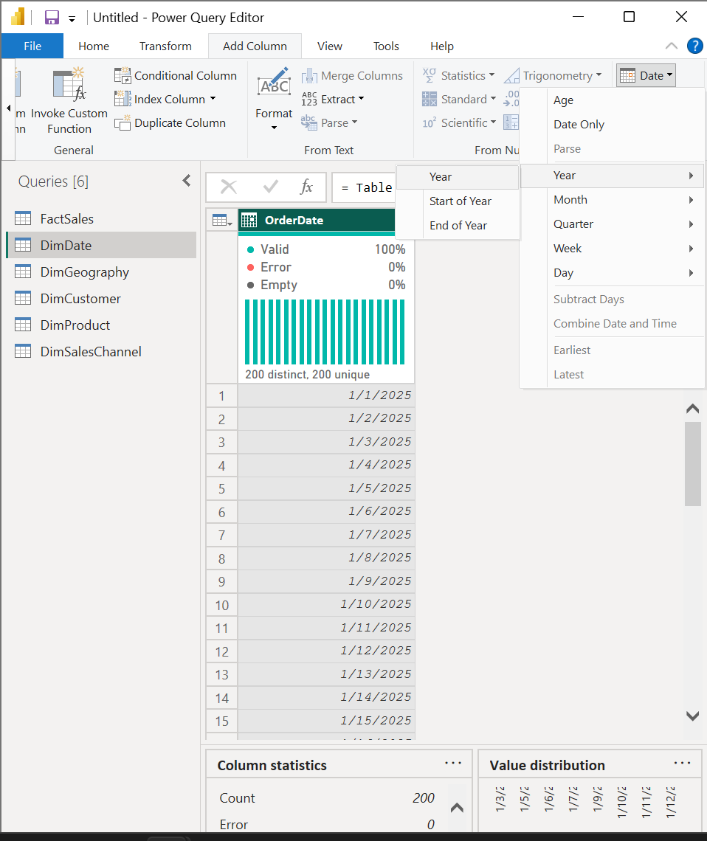

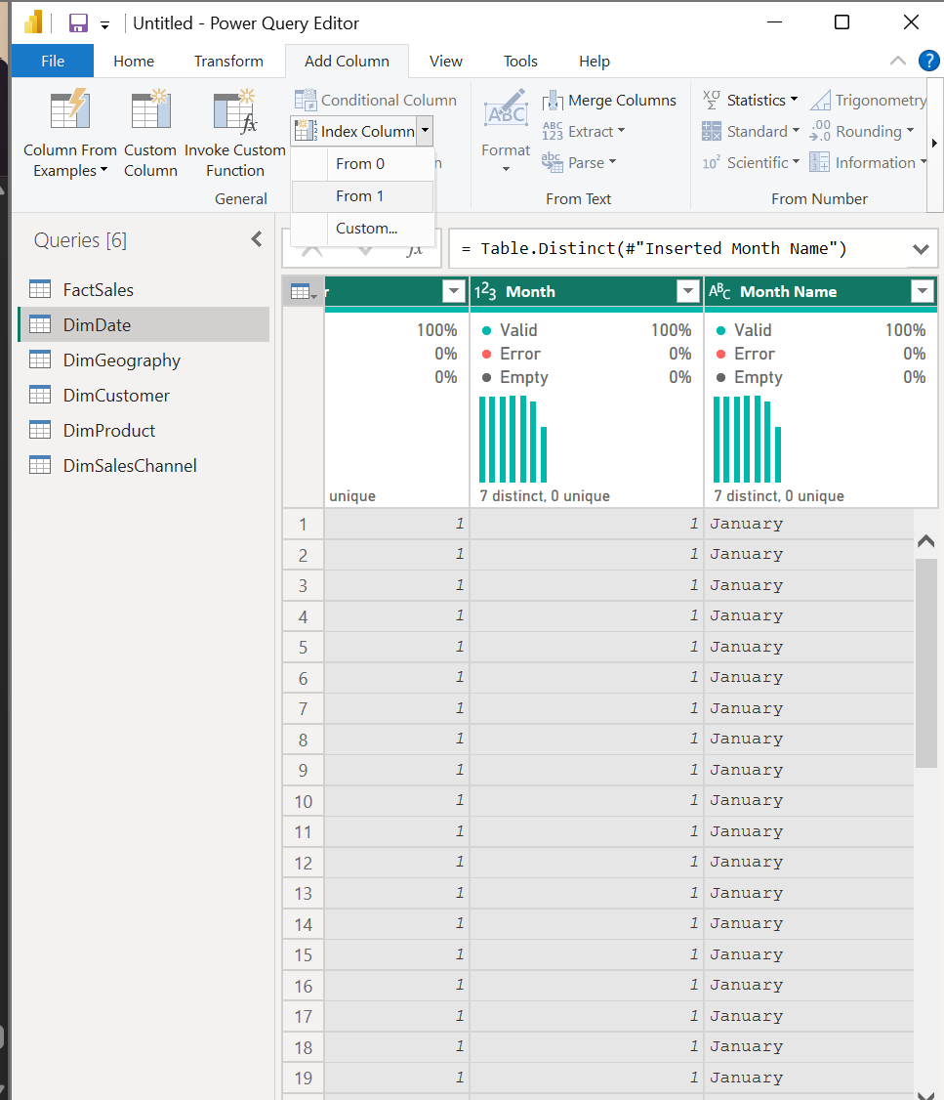

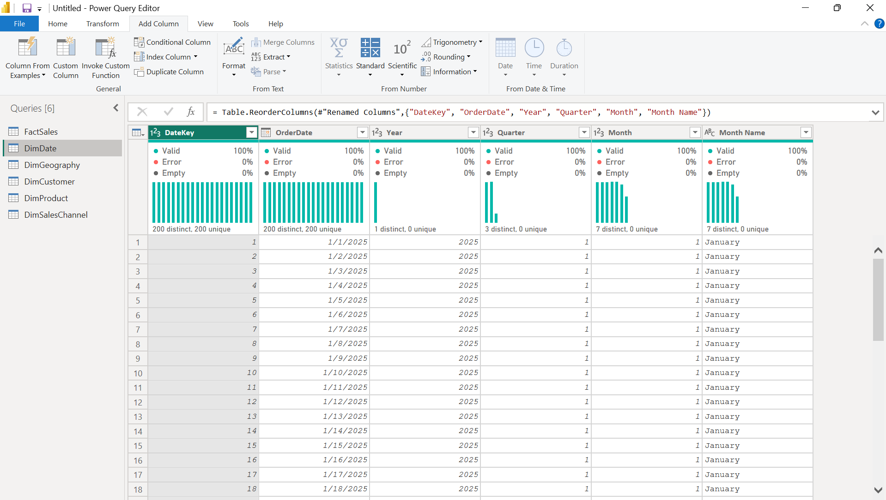

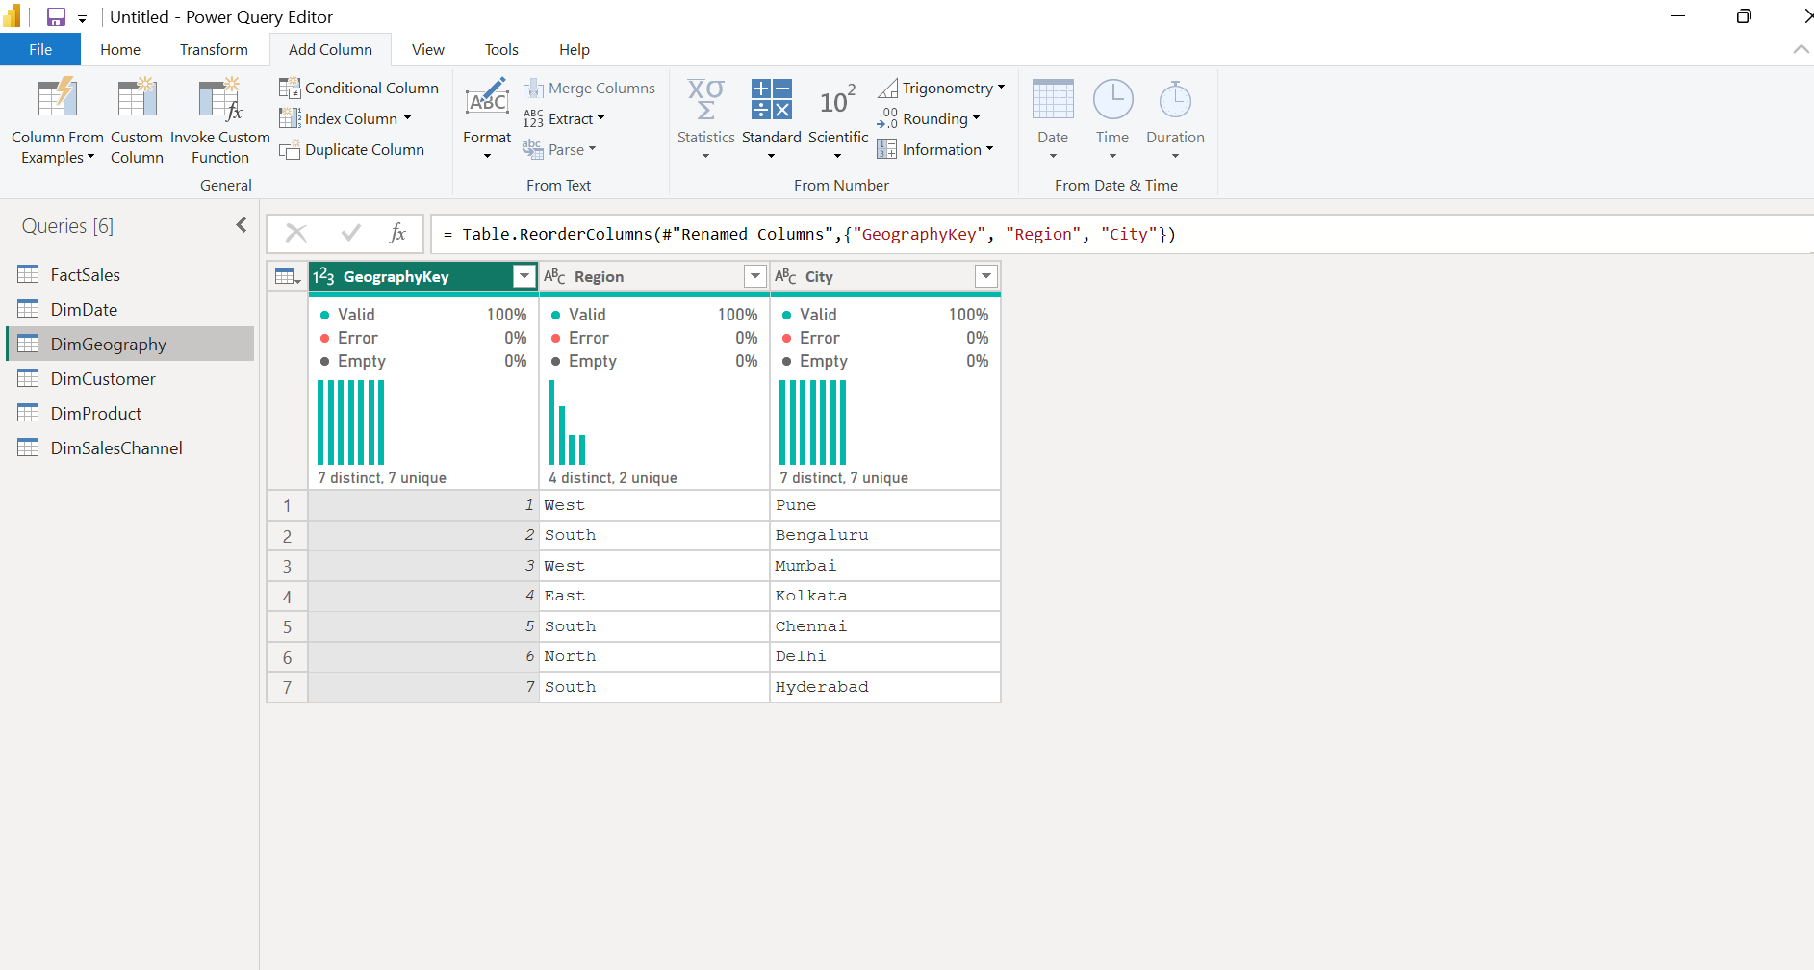
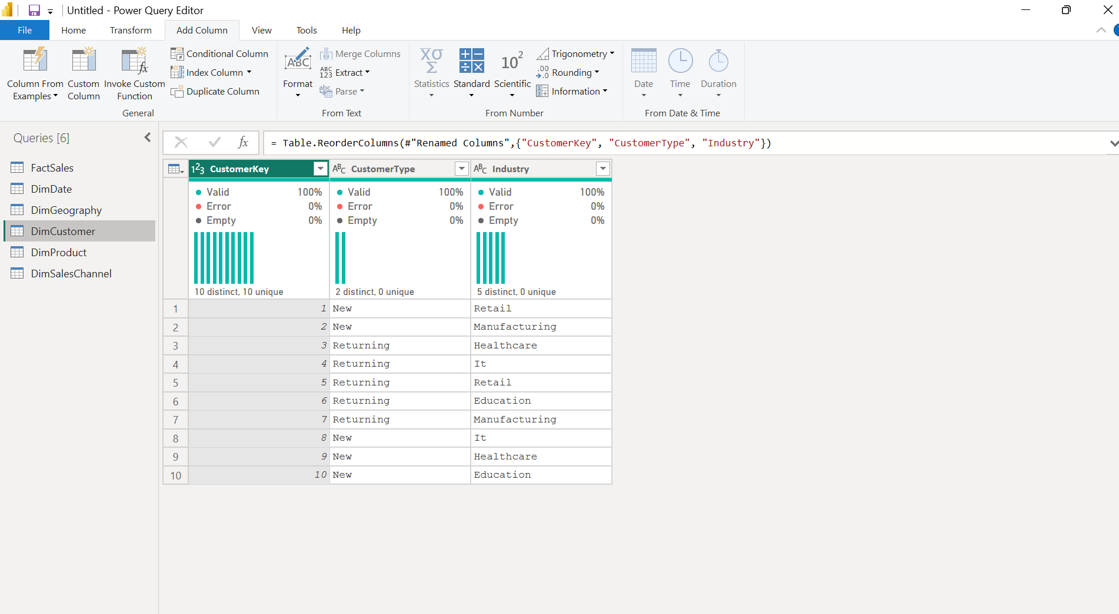
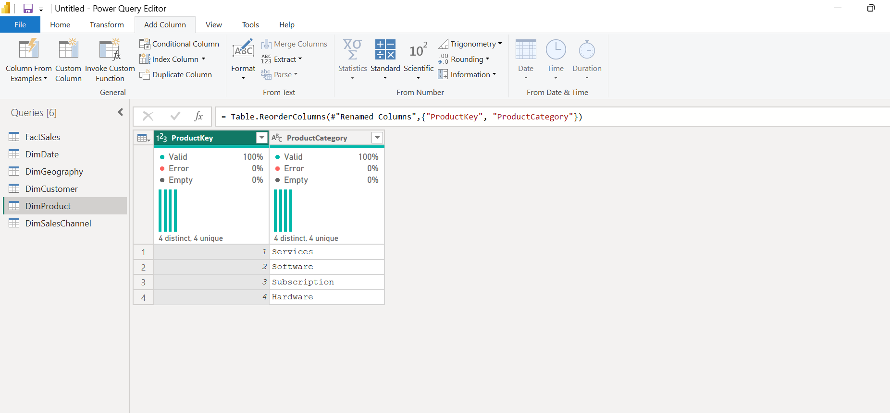
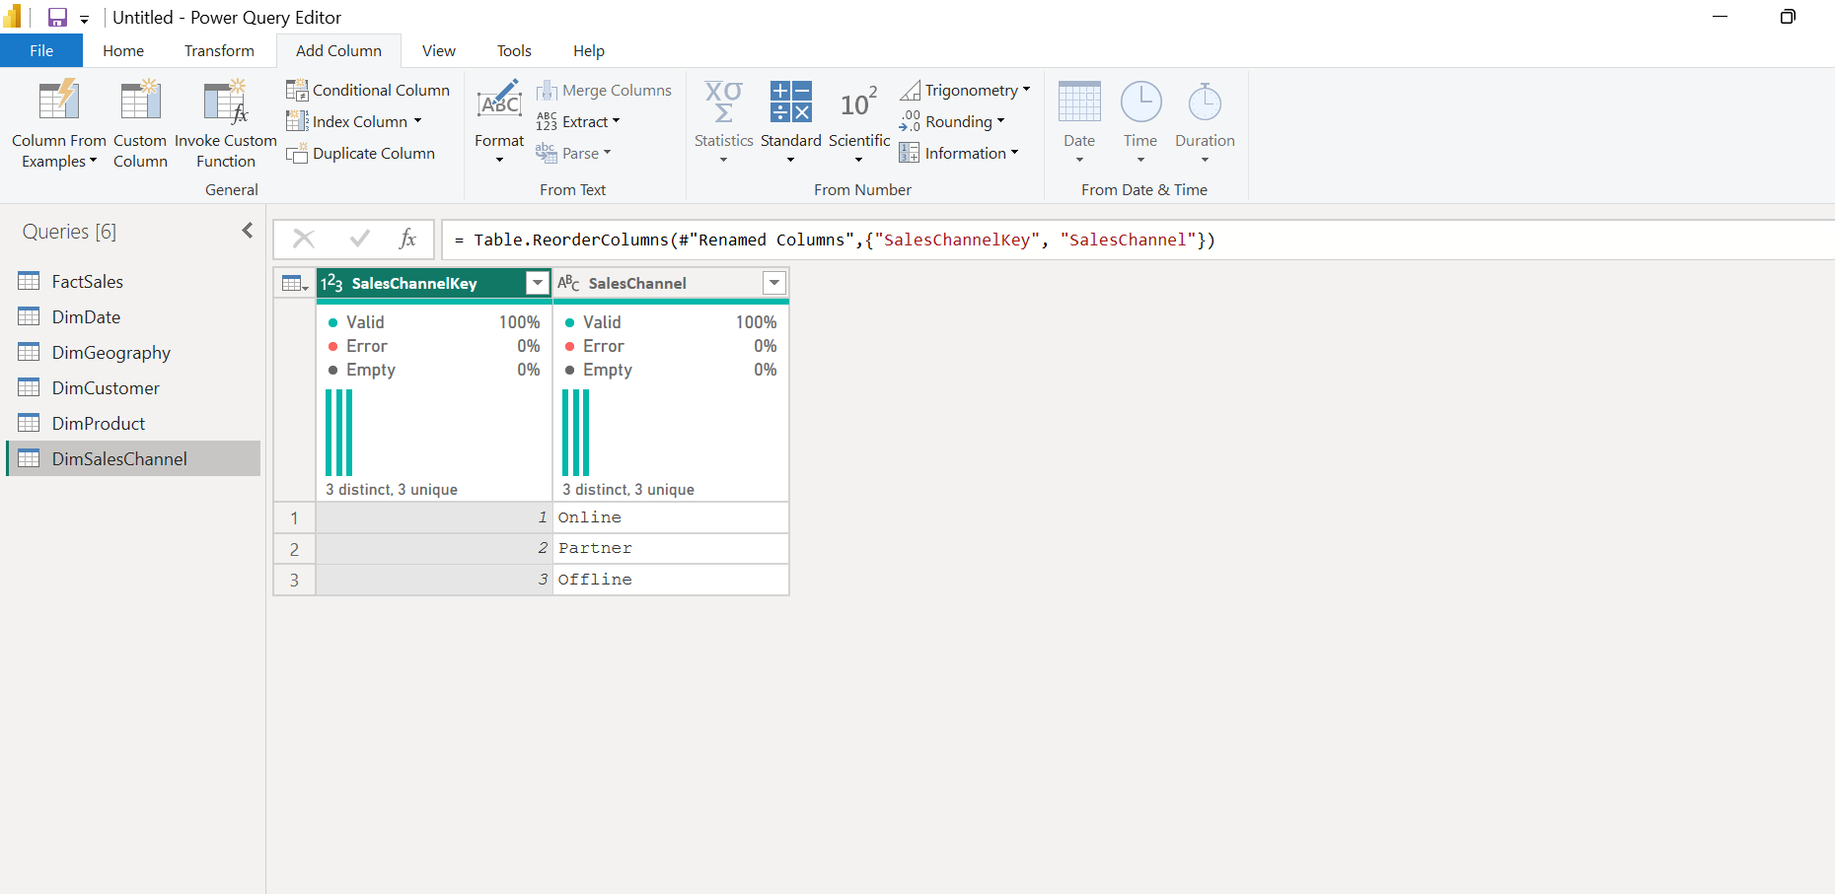

Part B: Exploratory Data Analysis
Step 5: Perform Data Profiling
In Power Query Editor, enable:
- Column Quality
- Column Distribution
- Column Profile
Observe:
- Valid values
- Error values
- Empty values
- Distinct values
- Unique values
- Data distribution
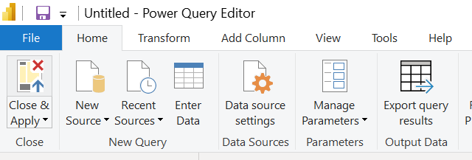

Step 6: Analyze the Dataset
Examine important fields such as:
- Sales
- Profit
- Cost
- Discount
- Customer Type
- Industry
- Region
- Product Category
- Sales Channel
- Order Date
Step 7: Create Basic Visualizations
Use Power BI visuals to understand sales patterns and distributions.
Examples:
- Sales by Region
- Sales by Product Category
- Sales by Sales Channel
- Sales by Month/Year
- Profit analysis
Part C: Star Schema Creation
Step 8: Create the Data Model
Load the cleaned tables into Power BI and open Model View.
The model consists of:
FactSales at the center, connected to: DimDate | DimGeography | DimProduct | DimSalesChannel
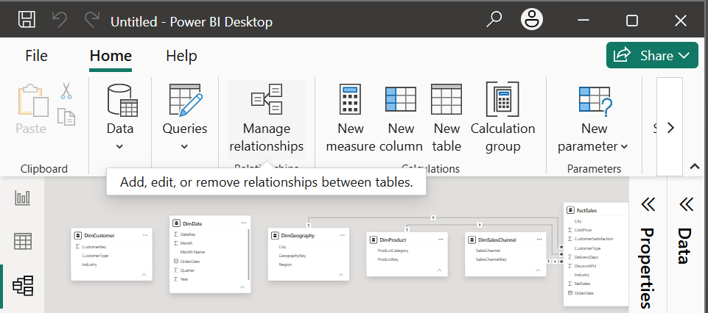
Step 9: Establish Relationships
Create the following relationships:
Fact Table | Dimension Table | Relationship
FactSales[City] | DimGeography[City] | Many-to-One
FactSales[OrderDate] | DimDate[OrderDate] | Many-to-One
FactSales[ProductCategory] | DimProduct[ProductCategory] | Many-to-One
FactSales[SalesChannel] | DimSalesChannel[SalesChannel] | Many-to-One
Ensure that the relationships are active and the appropriate filter direction is applied.
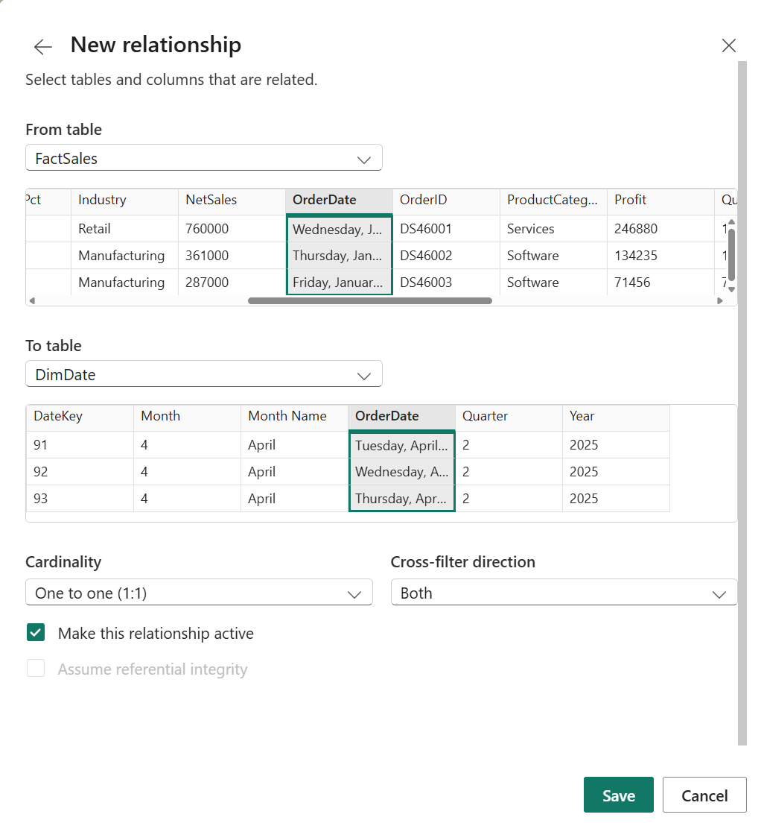
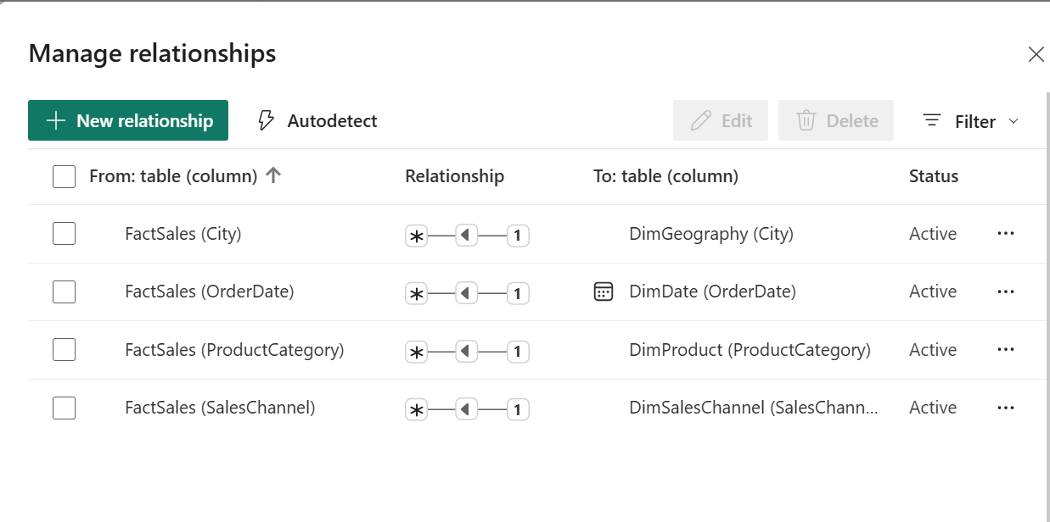
Fig: Relationships for star schema
Create the star schema:
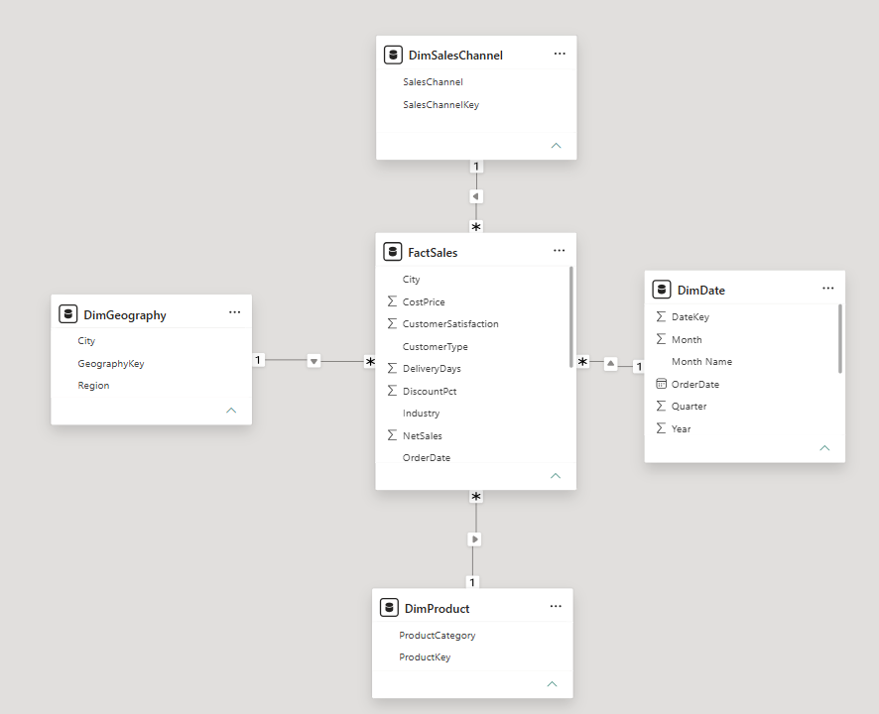
Fig: Star Schema
Part D: OLAP Operations
Step 10: Slicing
- Create a sales visualization.
- Add a Slicer visual.
- Add DimGeography[Region] to the slicer.
- Select one region, such as West.
- Observe how the dashboard displays sales only for the selected region.
Operation:
All Regions → West
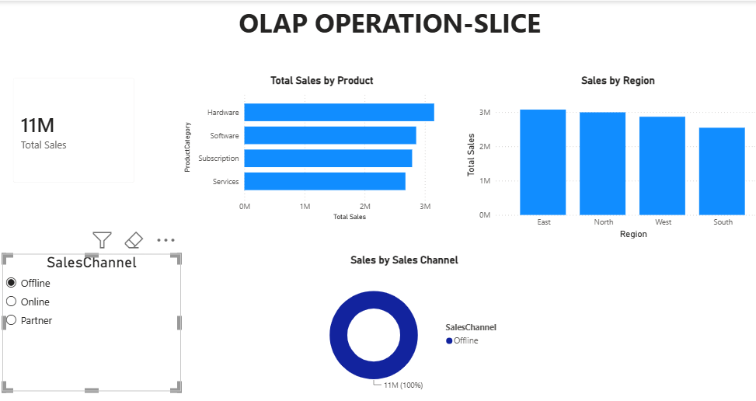 | 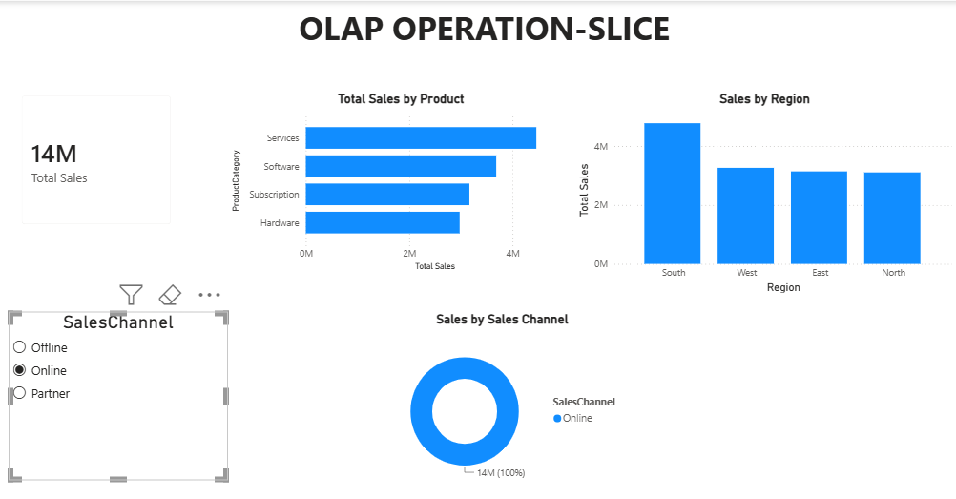
Fig: Slicing – Single Dimensional Analysis
Step 11: Dicing
- Add multiple slicers to the dashboard.
- Use:
  - DimGeography[Region]
  - DimProduct[ProductCategory]
  - DimSalesChannel[SalesChannel]
- Select required values from each slicer.
- Observe the resulting subset of sales data.
Example: West + Software + Online
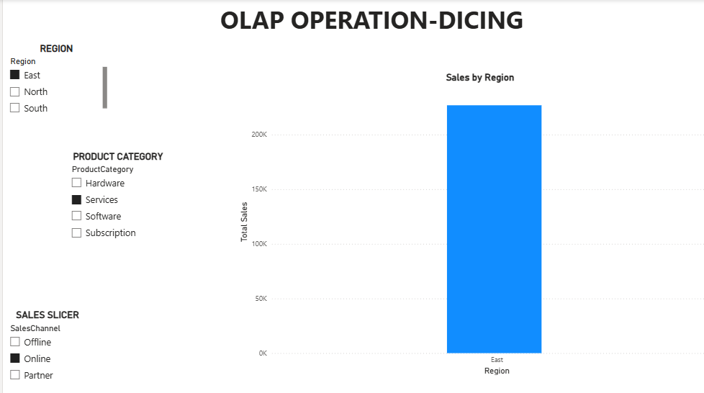 | 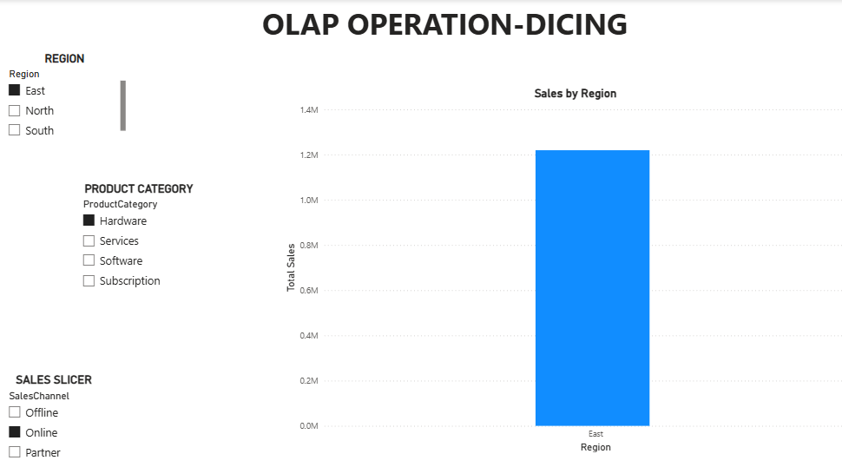
Fig: Dicing -Multi-Dimensional Analysis
Step 12: Drill-Down
- Create a date hierarchy using the DimDate table.
- Use the hierarchy: Year→Quarter→Month→Day
- Add the hierarchy to a suitable chart.
- Select the Drill Down option.
- Move from Year to Quarter, then Month and Day.
- Observe increasingly detailed sales information.
Operation:Year → Quarter → Month → Day
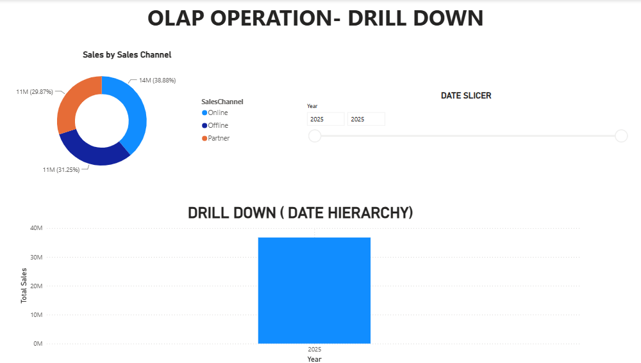
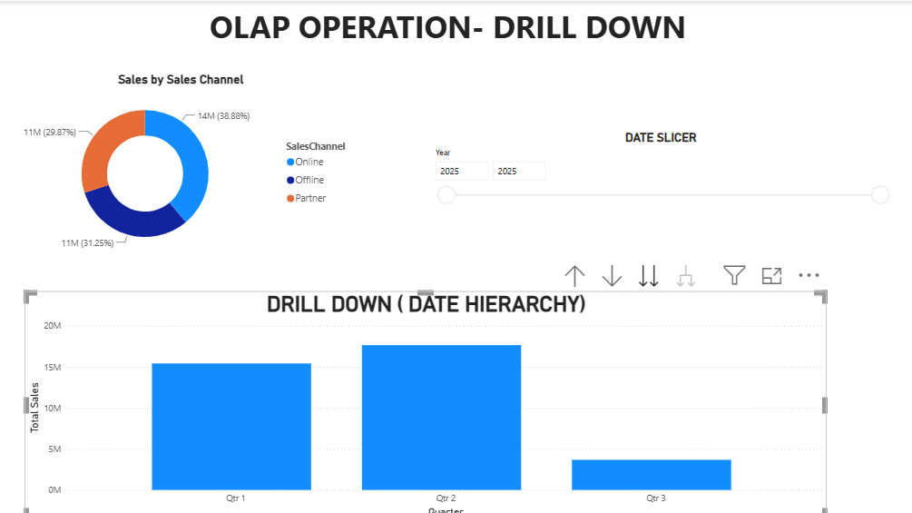
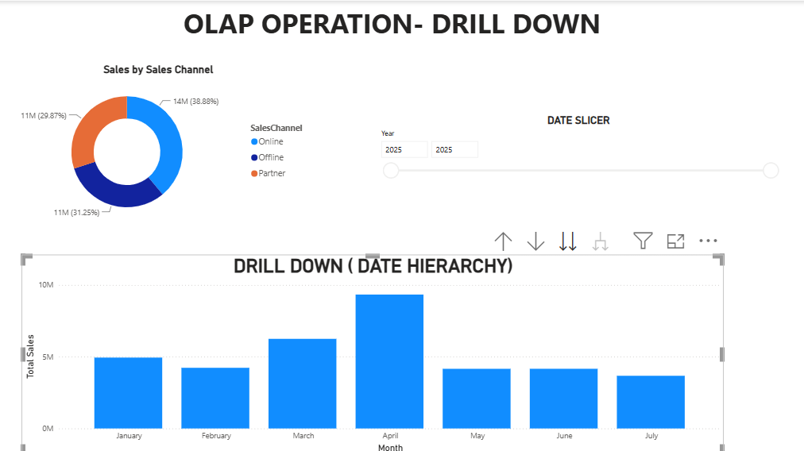
Fig: Drill Down (Date Hierarchy): Year->Quarter->Month
Step 13: Roll-Up
- Use the same date hierarchy.
- Start from the detailed level.
- Use the Drill Up option to move toward higher-level summaries.
- Observe the aggregated sales values.
Operation: Day → Month → Quarter → Year
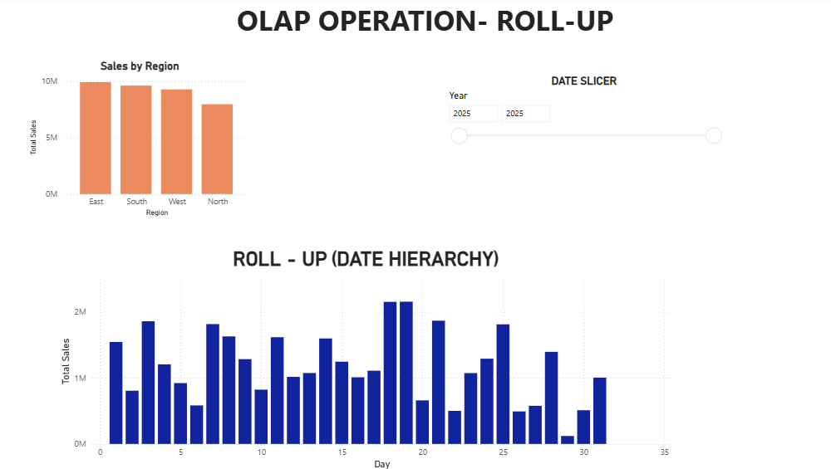
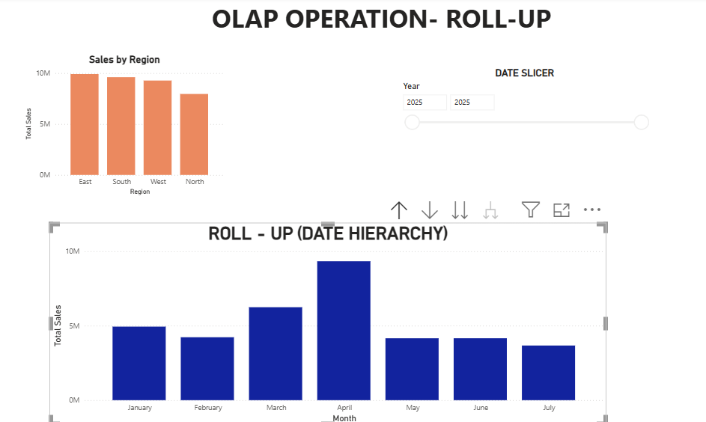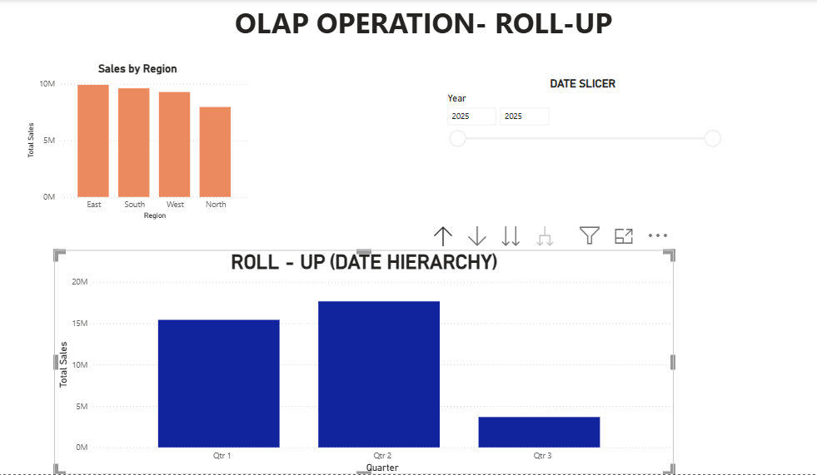
Fig: Roll Up (Date Hierarchy): Day-> Month->Quarter

Result:
The sales dataset was successfully preprocessed and analyzed using Power BI. EDA was performed to examine data quality and patterns. A Star Schema consisting of FactSales, DimDate, DimGeography, DimProduct, and DimSalesChannel was successfully created with appropriate relationships.
The dashboard was further used to demonstrate the OLAP operations:
- Slicing
- Dicing
- Drill-Down
- Roll-Up
The operations enabled multidimensional analysis of sales data across time, geography, product, and sales channel.
Learning Outcomes:
- Perform data preprocessing and data profiling using Power Query.
- Analyze and interpret datasets using EDA techniques and Power BI visualizations.
- Design a Star Schema and establish relationships between fact and dimension tables.
- Apply OLAP operations such as slicing, dicing, drill-down, and roll-up for multidimensional data analysis.

